Week 2: Data Collection, Cleaning, and Preprocessing for Logistics Analysis

1. Data Collection & Characteristics
The simulated dataset (Delivery_Logistics.csv) represents multi-modal distribution records containing trip distances, weather conditions, carrier identities, financial costs, and raw transit timestamps.

2. Preprocessing Architecture
+------------------------------------+
| 1. Ingestion: Raw Logistics CSV |
+------------------------------------+
│
▼
+------------------------------------+
| 2. Drop Unique Identifiers | --> df.drop(columns=['delivery_id'])
+------------------------------------+
│
▼
+------------------------------------+
| 3. String Parsing & Conversions | --> Extract fractional numeric hours
+------------------------------------+
│
▼
+------------------------------------+
| 4. Statistical Imputation | --> Mean (Numeric) / Mode (Categorical)
+------------------------------------+
│
▼
+------------------------------------+
| 5. Feature Synthesis (CPK) | --> cost_per_km = delivery_cost / distance_km
+------------------------------------+

3. Cleaning & Feature Engineering Script
Python
import pandas as pd

# Fix corrupted timestamp strings by extracting the fractional numeric value
df['delivery_time_hours'] = pd.to_numeric(df['delivery_time_hours'].astype(str).str.split('.').str[-1], errors='coerce')
df['expected_time_hours'] = pd.to_numeric(df['expected_time_hours'].astype(str).str.split('.').str[-1], errors='coerce')

# Handle missing numerical values via column mean
df = df.fillna(df.mean(numeric_only=True))

# Handle missing categorical values via column mode
df = df.fillna(df.mode().iloc[0])

# Feature Engineering: Normalized delivery cost per kilometer
df['cost_per_km'] = df['delivery_cost'] / df['distance_km']

print("Cleaned Data Shape:", df.shape)
df.info()

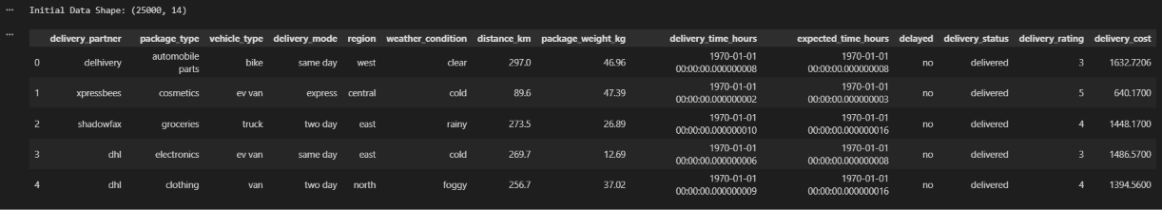

4. Methodological Rationale
- Identifier Elimination: Dropping delivery_id prevents algorithms from memorizing non-generalizable sample keys.
- String Parsing: Handles dot-separated string formats in time records and converts them to standard floating-point numerical values.
- Imputation Strategy: Mean imputation preserves numerical central tendencies, while mode imputation ensures categorical completeness without dropping records.
- Cost Normalization: Normalizing total expense by trip distance (cost_per_km) prevents long-distance trips from distorting partner efficiency ratings.

